Walking through a war zone: Ethiopians heading for Saudi – in pictures
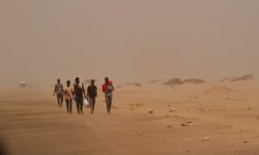
Global development is supported by
Escaping poverty and drought, Ethiopians are making the dangerous sea crossing from Djibouti to Yemen and then on foot to the Saudi border. Many only realise they are crossing a conflict zone when they are picked up by gangs or militias
Photographs by Susan Schulman
Main image: Ethiopians are making the long journey mostly on foot, through some of the most extreme environments in the world. Photograph: Susan Schulman
Tue 27 Aug 2019 11.00 BST
Ethiopians m ake their way across Djibouti on foot, carrying nothing but water bottles which they fill when and where they can. They are bound for Yemen and then Saudi Arabia, seeking work opportunities
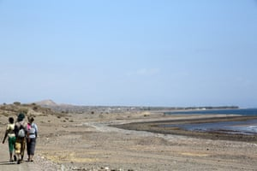
Ethiopians Obsa (left), from Bale, and Bashir (right), from Jimma, take a rest while eating the bread given to them by Djiboutians in a passing car
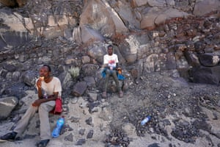
The reception centre in Obock, Djibouti, run by the International Organization for Migration (IOM). Here Ethiopians heading to Yemen and Saudi are asked if they want to return to Ethiopia or carry on with their trip. The centre offers them a brief rest and medical care
Migrants congregate at Fantahero beach, Djibouti, awaiting a call from their ‘connection’ to tell them when a boat is ready to take them on the perilous Red Sea crossing to Yemen

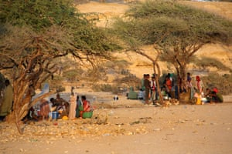
Ethiopians are continuing to make the lengthy and dangerous journey, despite a crackdown by the Saudi authorities. Roughly 10,000 Ethiopians have been deported every month from the Gulf state since 2017
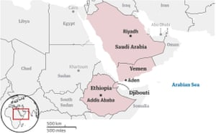
Arriving in Yemen many migrants are immediately picked up by gangs. Some report being taken to a makeshift jail in the middle of the desert, where they say they are forced to call their families so they can then hear them being tortured, beaten and abused in an attempt to extort money. Some die at the hands of the gangs, many of those who survive have scars to show for it. If they are released, the now penniless migrants usually sleep rough. They try to earn any money they can in any way to enable them to continue their long journey
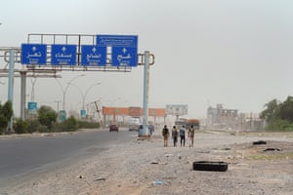
Ahmed Muhammed (left), 20, Muhammed Ibrahim (middle), 15, and Ibrahim Sultan (right), 25. Ahmed left a small farm near Harar, Ethiopia, three months ago. There was no rain and no money. ‘We only heard about the war [in Yemen] near the port. If we had known, we wouldn’t have come. But we didn’t have the money to go back. In the village, the trafficker said [we would] not walk. They were Somalis. We paid $450 (£370). They promised cars would take you all the way. Some are entering Saudi and having success. Now it is harder. I am afraid but we have a deal with our family to travel and get work and help’
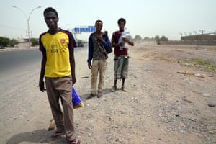
Fuad Abdullah (left), 25, from Jimma, and his companion Abdullah Ali, 19, have just escaped from from abductors who they say beat them. ‘They ask for money and if there is money they let you go and if not, they will kill us.’
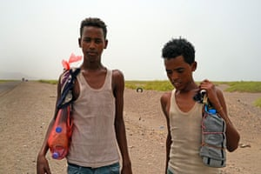
Migrants rest amid the ruins of a bombing, roughly 80km inland on the journey to Aden, Yemen. Small bands can be seen walking in sandstorms and up mountains. All hope to avoid injury in the war as they cross into fighting areas. They also try to evade the round-ups, which began some months ago, depositing migrants at a bombed-out stadium in Aden to await deportation
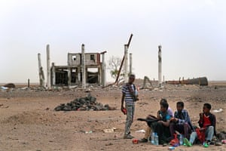
Cairo roundabout, Aden, where migrants rest before continuing their journey. Few speak any Arabic. Many say they have lost weight and do not know what they will eat today
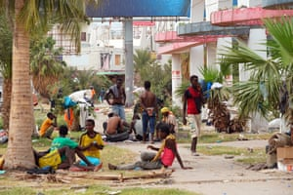
Ibrahim Jundi, 25, wears a beaded bracelet bearing the word ‘lucky’. Intent on reaching Saudi, he is undaunted by the prospect of crossing through an active war, but has found roadblocks on all sides. The Yemeni army accuses migrants of fighting with the Houthis. Ibrahim says this is not true, and that while he and other migrants have been offered money to fight with various militias, they always say no. Nonetheless, the army blocks their way
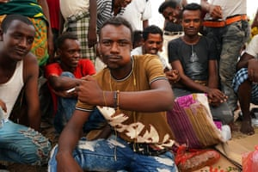
About 2,000 Ethiopians are staying in a bombed-out football stadium in Aden awaiting repatriation. Migrants continue to be impacted by strict immigration policies in the city. At the peak of the detention campaign, IOM estimates that approximately 5,000 people were held across three sites
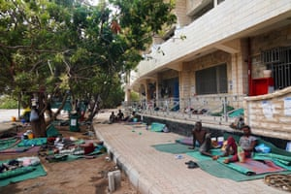
Ali Muhammed Sadiq, 27, wearing a US flag shirt, says: ‘It was a big mistake to come four months ago. As soon as we came out of the boat they caught us and took us to a jail in the desert. They beat me before letting me go. Others lost arms, legs and eyes. The kidnappers took plastic bottles and punched it into the eye. Life has stopped. We can’t go home. We can’t go to Saudi. We can’t find jobs. We are stuck. Going back can’t be as bad but the community and my family will be disappointed that I failed. Some borrowed money to come. They are afraid of the problems they will find at home
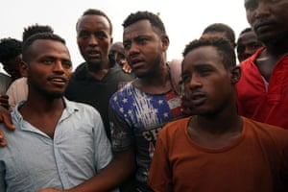
Some have been brought here in migrant round-ups. Others have come in the hope of getting food, but say they only get food here once a day
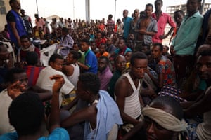
The conditions are difficult and toilet facilities lacking. Some sleep on mounds of rubbish
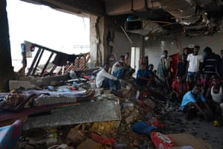
Hamano Nuria, 12 , from Mersa, is at the stadium. He stole in order to leave Ethiopia, hoping to make the money he saw others who had made it to Saudi had earned. He regrets having come. He feared returning home until he managed to phone his mother, who promised him she would accept him back despite the theft
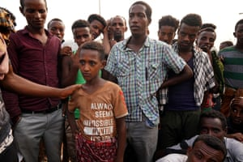
On 28 May, as a last resort, IOM began supporting voluntary humanitarian returns. There have been delays. Flights require approval from the governments of Saudi Arabia and the United Arab Emirates, as well as the government of Yemen
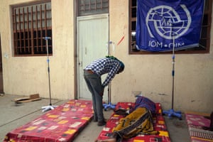
However, nothing puts some migrants off their determination to reach Saudi, in part fuelled by the fear of returning home to debts incurred by the effort to save for the journey
